White Bean and Garlic Scape Dip
Ingredients:
1 15 oz. can garbanzo beans, rinsed and drained
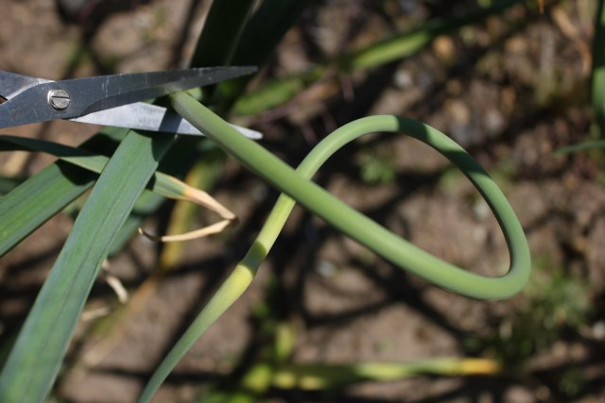
1/3 cup chopped garlic scapes
juice of 1 lime
1/3 cup snipped cilantro
3 tablespoons olive oil
3 tablespoons mayonnaise
salt to taste, about 1/2 teaspoon
Instructions:
Combine all ingredients in the base of a food processor fitted with blade. Pulse until smooth and all ingredients are incorporated. Add salt to taste. Adjust if necessary. Spread on a cracker to serve.

Radish Canapes with Black-Olive Butter
Ingredients:
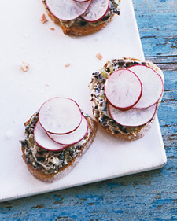
16 oil-cured black olives, pitted and finely chopped
2 scallions, finely chopped
3 tablespoons finely chopped fresh mint
4 ounces (1 stick) unsalted butter, softened
Freshly ground pepper
1 baguette, thinly sliced crosswise and toasted
5 red radishes
Directions:
Blend olives, scallions, mint, and butter in a food processor workbowl. Season with pepper. Spread olive butter onto each baguette slice. Thinly slice radishes. Layer 2 or 3 slices on top of each canape.
Prim’s Sweet Goat Cheese Salad
Historically, goats represent sacrifice and giving. When Prim sells most of her goat cheese at the Hob, she sacrifices so her family can eat. However, she could make this salad for her own family using natural ingredients found by her sister and Gale in the forest. (Hunger Games, Chapter 3)
Ingredients:
1 pound spinach, rinsed and torn into bite-size pieces
1 ½ c Cherry tomatoes
½ c dried cranberries
½ c Crumbled Goat cheese (or feta)
Salad Dressing
Directions:
Cut cherry tomatoes in half. Separate dried cranberries by hand. Toss all ingredients in a large bowl. Drizzle the salad dressing over your individual salad and enjoy.

Prim’s Basil-wrapped Goat cheese Balls
One of the very first mentions of food in The Hunger Games trilogy comes in the form of a gift from Prim. On Reaping Day, prim presents her beloved big sister with a gift- goat cheese wrapped in basil leaves. When Prim gives Katniss this goat cheese she foreshadows the many sacrifices the Everdeen family will be forces to make when Katniss volunteers to take Prim’s place in the Hunger Games. (Hunger Games, Chapter 1)
Ingredients:
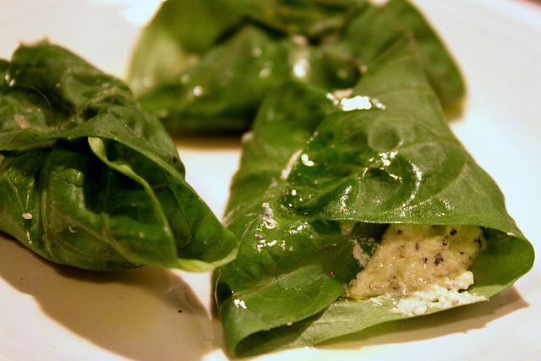
5 oz of goat cheese, at room temperature
1 T. extra-virgin olive oil
½ t. fresh lemon juice
Pinch of sea salt
½ t freshly ground black pepper
25 large basil leaves
Crackers
Directions:
In a small bowl, stir together the goat cheese, olive oil, and lemon juice. Add salt to taste. Place a spoonful of the cheese mixture onto each basil leaf and roll the basil leaf closed. Drizzle with olive oil and serve on a cracker.

